



**Candidate Number 1184**

Center 52423

**Project Management CRM**

**A Computer Science Project**

Written By

**Luke Hodges**

Table of Contents

About Us 3

Vision and Mission 3

Core Values and Philosophy 3

Methodology 4

Problem 5

Solutions 6

Roadmap 7

Financial Prospect 8

Team 10

Prepared on

**September 1st 2024**

# Analysis

Nexus Growth Strategies is an avant-garde business consultancy firm that specializes in propelling small and medium-sized enterprises (SMEs) toward remarkable growth trajectories. Established in 2078, our headquarters reside in the bustling financial hub of New York City, an epicenter for global commerce and innovation. Nexus stands as a beacon for businesses seeking to navigate and conquer the complex challenges of modern markets.

## Problem Statement

## User Requirements

## Stakeholders

## Market Research

## Solution Requirements

## Proposed Solution

## Use Cases

## Shareholders evaluation

## Requirements – Project Breakdown

### User Requirements & Features

### Data Requirements

### Hardware & Software Requirements

### Architectural Considerations

# Design

## Problem Decomposition

## Systems Architecture (Clean Architecture Model)

## Clean Architecture Model

## Entities

## Use Cases

## Database Repositories

## Presentation

## Implementing Testing

Our approach is analytical yet creative, rooted in data but reaching for the innovative. The Nexus Methodology operates in four key stages:

**Discovery & Analysis**

**Strategy Formulation**

**Implementation Planning**

**Evaluation & Iteration**

Through workshops and deep analytics, we uncover the nuances of each client’s business landscape, competitors, and internal dynamics.

Leveraging our findings, we craft tailored strategies that address identified needs while capitalizing on market opportunities.

Strategies are translated into actionable plans, with clear steps, milestones, and metrics for success.

Post-implementation, we analyze outcomes, iterate, and refine strategies to ensure ongoing improvement and adaptation.

# Testing

In the current business landscape, small and medium-sized enterprises face multifaceted challenges that can hinder their ability to compete and thrive. The barriers to growth are often deeply interwoven within the fabric of a company's structure and market conditions. Nexus Growth Strategies has identified several core problems that our clients frequently encounter, which are critical to address for sustainable development.

**1**

**Market Penetration Difficulties:** SMEs often struggle to gain a foothold in markets dominated by larger entities with more resources. The high costs of marketing, along with the difficulty in establishing brand recognition, create a steep pathway to visible market presence and customer loyalty.

**2**

**Operational Inefficiencies:** Many SMEs are hampered by outdated processes and technologies, leading to operational inefficiencies that drain resources and reduce competitiveness. Without lean and efficient processes, these businesses lag in their ability to adapt quickly to market changes or scale effectively.

**3**

**Talent Acquisition and Retention:** The competition for skilled talent is fierce, and SMEs frequently find themselves at a disadvantage. Attracting and retaining top talent requires a combination of competitive compensation, growth opportunities, and a dynamic work environment, which smaller businesses often struggle to provide.

# Maintainance

Nexus Growth Strategies has devised a suite of strategic solutions tailored to address the key challenges faced by SMEs. Our innovative approaches are designed to turn these hurdles into springboards for growth and competitiveness.

**1**

**Enhanced Market Penetration Approach:**To overcome market entry barriers, we implement a multi-tiered marketing strategy that combines digital presence optimization with targeted outreach programs. Leveraging social media analytics and SEO, we elevate brand visibility and create compelling value propositions that resonate with the desired customer base. Collaborations with influencers and strategic partners are also harnessed to amplify brand recognition and trust.

**2**

**Process Optimization and Tech Upgrade:** Addressing operational inefficiencies, our solution involves a comprehensive review of current processes followed by the integration of lean management principles and the adoption of cost-effective, cutting-edge technologies. By automating routine tasks and streamlining operations, we empower SMEs to focus on core business growth activities while reducing operational costs and improving response times.

# User Guide

The roadmap designed by Nexus Growth Strategies outlines a strategic plan to transition from the current state to the desired future state, where the proposed solutions are fully operational. The roadmap is presented in four key phases, each with distinct objectives and actions.

|  |  |  |  |
| --- | --- | --- | --- |
| **Step** | **Action Item** | **Description** | **Timeline** |
| 1 | Market Analysis & Strategy Development | Conduct a thorough market analysis to understand the competitive landscape and develop a detailed marketing strategy. | Month 1-3 |
| 2 | Operational Revamp & Tech Integration | Assess current operations, initiate process optimization, and integrate new technologies to improve efficiency. | Month 4-6 |
| 3 | Talent Management System Implementation | Design and implement a talent management system to enhance recruitment, retention, and employee development. | Month 7-9 |
| 4 | Financial Restructuring & Capital Formation | Restructure financial practices and explore diverse funding sources to improve capital availability. | Month 10-12 |

# Financial Prospect

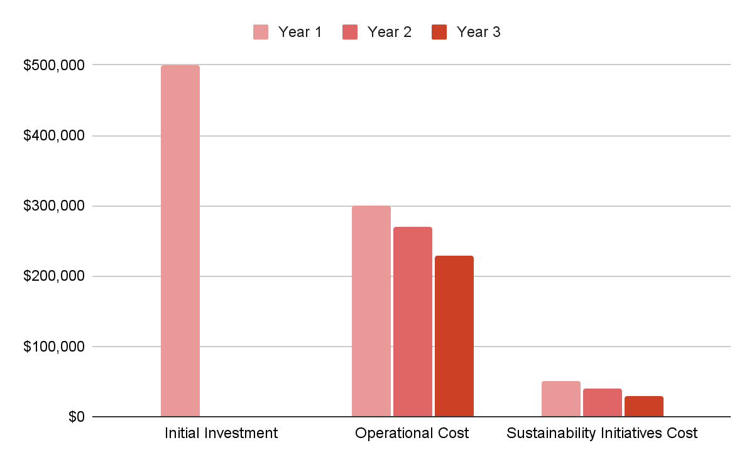

|  |  |  |  |
| --- | --- | --- | --- |
| **Financial Aspects** | **Year 1** | **Year 2** | **Year 3** |
| Initial Investment | $500,000 |  |  |
| Revenue Growth |  | +10% | +15% |
| Cost Savings | -5% | -10% | -15% |
| Operational Cost | $300,000 | $270,000 | $229,500 |
| Net Profit | - | - | - |
| ROI | - | - | +20% |
| Sustainability Initiatives Cost | $50,000 | $40,000 | $30,000 |

The financial blueprint of Nexus Growth Strategies revolves around creating robust economic foundations for our clients, enabling them to realize growth while ensuring sustainability. We prioritize a thorough financial analysis to guide SMEs in navigating the complexities of financial management, investment, and revenue optimization. Here’s how we tackle the financial dimension:

**Cost Analysis and Management:** Our initial step involves a meticulous evaluation of current expenditures, identifying areas of unnecessary spending and potential savings. We introduce cost management strategies tailored to the company's size and sector, optimizing the use of financial resources.

**Revenue Projections:** With the implementation of our tailored solutions, we project a realistic increase in revenue streams over the next fiscal periods. Our projections are based on data-driven market analysis, historical performance, and the expected impact of strategic initiatives on sales and market share.

**Investment Planning:** The financial roadmap includes a detailed investment plan outlining critical areas for capital infusion, such as technology upgrades, marketing campaigns, and talent acquisition. This plan aligns with projected cash flows to maintain financial stability.

|  |  |  |
| --- | --- | --- |
| **Metric** | **Target** | **Description** |
| Revenue Growth | +10-15% YoY | Annual increase in revenue, reflecting successful market penetration and sales strategies. |
| Operational Cost Saving | -10% YoY | Reduction in operational expenses through improved processes and technological efficiencies. |
| Net Profit Margin | +5-10% YoY | Increment in net profit margin, resulting from increased revenue and controlled spending. |
| ROI | 20-30% in 3 Years | Expected return on investment over a three-year period post-implementation of strategies. |

# Team

At the heart of Nexus Growth Strategies is a team of diverse, seasoned professionals whose expertise powers the transformation of SMEs. Our leadership team brings together a synergy of experience, innovation, and strategic acumen.

**Elena Martinez**

Co-Founder & CEO

With over 15 years of experience in business development and strategic planning, Elena is a visionary leader who has propelled multiple businesses from modest startups to industry contenders. Her keen insight into market trends and her ability to forecast economic shifts have been pivotal in formulating growth strategies that are both resilient and dynamic.

**Dr. Rajiv Chopra**

Chief Analyst

Dr. Chopra holds a Ph.D. in Business Analytics and brings a wealth of knowledge in data-driven decision-making to the team. His expertise in market analysis and performance metrics has been instrumental in developing the robust analytical frameworks that underpin our strategic advice. Rajiv’s innovative approaches to big data have redefined how we measure success and optimize business processes